***ELECTRONIC VOTING MACHINE***

ABSTRACT:

Voting is the fundamental right for each citizen of a country. The same scenario is also noticed in our country. Bangladesh is a democratic country. So, in a democratic country like ours every eligible citizen has the right to choose his/her preferred candidate. For that to be happened we need to make sure that the election process is fair and accurate.

So, for making the election process fair and accurate we need to change the current system. Currently, votes are taken manually in our country. The manual system is not very accurate and fair enough. There is always a chance of cheating and misconduct in the current system. So, for avoiding those scenarios we have constructed a device called “ELECTRONIC VOTING MACHINE”. It is an electronic device which receives and calculates votes. Then, it declares the winner. We hope it will solve almost all the problems and election results will be fair and accurate.

INTRODUCTION:

1. PROJECT IDEA:

Electronic Voting Machine (EVM) is a device by which people can give their votes digitally. Because of using this system we don’t have to use ballot papers, ballot boxes, markers etc. EVM is very easy to use. The manual system was difficult to understand for some people but EVM is very easy to understand for everyone. In the past, there was always a speculation of cheating and misconduct in any election of our country. So, for changing the history we definitely need something like EVM.

EVM is an electronic device which will have some buttons. There will be separate button for each party and also there will be a button for calculating result. Each voter will press his desired button and the information will be saved. So, the mechanism of the device is very much simple. We can say that EVM will be a history changing device and everybody will like it. So, this is the project idea.

1. HOW OUR PROJECT WORKS:

* People can press a button of the machine and give their valuable vote whoever they want.
* The machine will store the information, and calculate the amount of total votes.
* The final result of the election will be displayed on the LCD screen of this machine.

Simply we can say, in this project we have used four push buttons for four different candidates. We can increase the number of candidate but for better understanding we have limited it to four. When any voter press any of four button then respecting voting value will increment by one each time. After whole voting we will press result button to see the results. As the "result" button is pressed, Arduino calculates the total votes of each candidate and show it on the LCD display.

1. WHAT OTHER THINGS TO DISCUSS NEXT:

There are many things left to discuss.

* First of all, we’re going to discuss about the background of our project. In that part, we will mention the sources from where we have got our idea. Also, we will inform about the components that we have used to complete this project.
* After that, we will describe about our working procedure. Here, we will also discuss about the result and simulation of our project.
* Then we will talk about our future work.
* Last but not the least, we are going to give a concluding message.

So, these are the thing which will come next.

BACKGROUND:

1. COMPONENTS:

* Arduino Uno
* 16x2 LCD
* Push Button
* Bread Board
* Power
* Connecting Wires
* Resistors
* Finger Print Module

1. SOURCE OF IDEA:

We always wanted to do something innovative as our “JUNIOR DESIGN” project. SO, we have searched a lot for the right idea. Finally, we have decided to make an “ELECTRONIC VOTING MACHINE” as we find that really fascinating. We have studied a lot online from different websites. But our project is mainly inspired by a website. The link of that website is given below:

<https://circuitdigest.com/microcontroller-projects/fingerprint-based-biometric-voting-machine-arduino?fbclid=IwAR3urRcHZS06pIVzlhetET8d9lbAsdiRQxMfrhIwRqbP9QpfJ5o22760iXY>

<https://circuitdigest.com/microcontroller-projects/electronic-voting-machine-using-arduino?fbclid=IwAR0nrLFAvbGtwz7kRugLMMM9URyprqlXbw40GZYq3xMXPB_yr2xbbB5aJR4>

So, we have mainly studied all the topics of those links.

OUR WORK:

1. WORKING PROCEDURE:

Firstly, we made a time plan and started to work according to that. That particular time plan is given below:

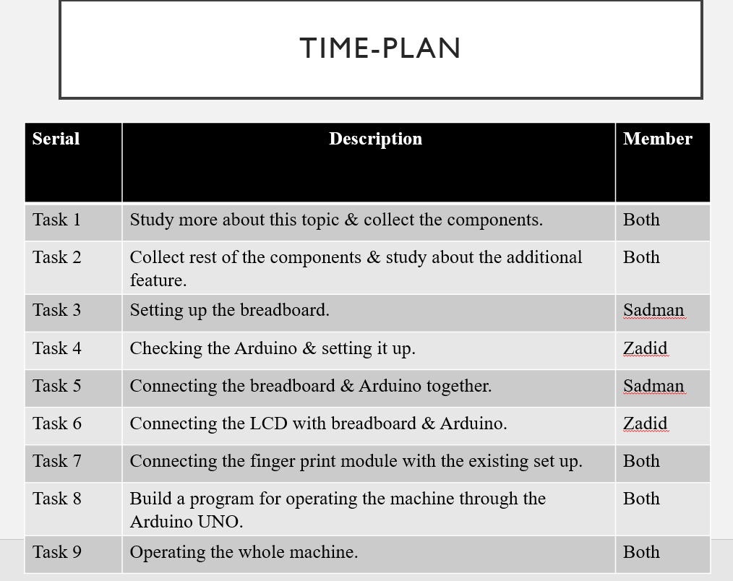

Firstly, we have followed the circuit diagram given below:

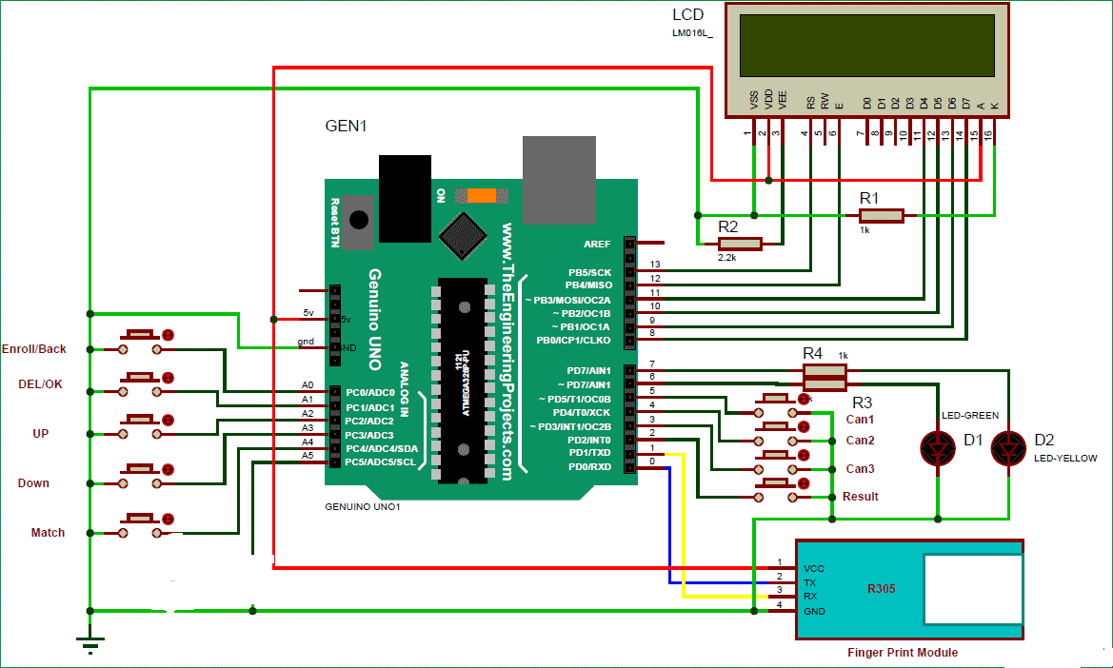

But when our fingerprint sensor was not working then we have followed another circuit diagram which is given below:

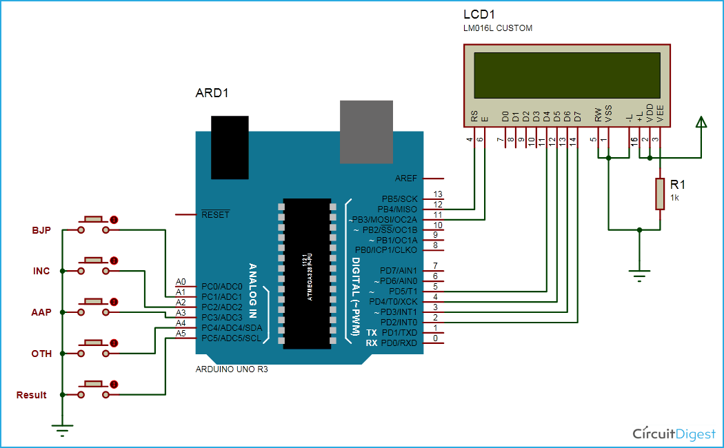

Thus, we have completed our hardware part by following this circuit diagram.

For operating the machine we have written a program by using C++. We have uploaded it on github and link is given in the last part of the report.

1. BUDGET:

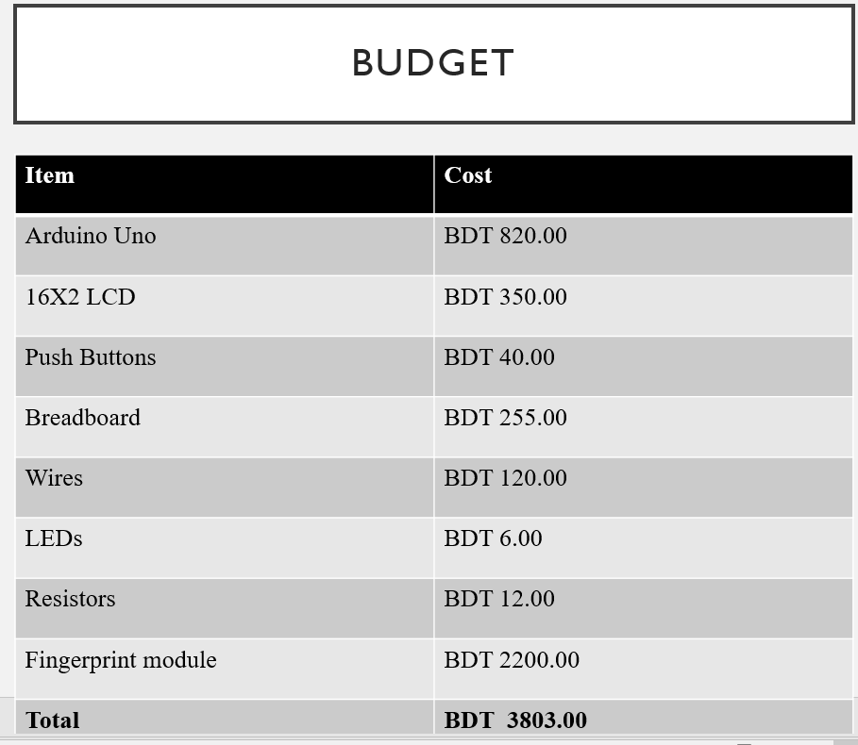

1. RESULT & SIMULATION:

By operating this machine, we will get the final result of the election and the final result will be displayed on the LCD screen. The result must be accurate and precise.

Some screenshots of our machine is given below:

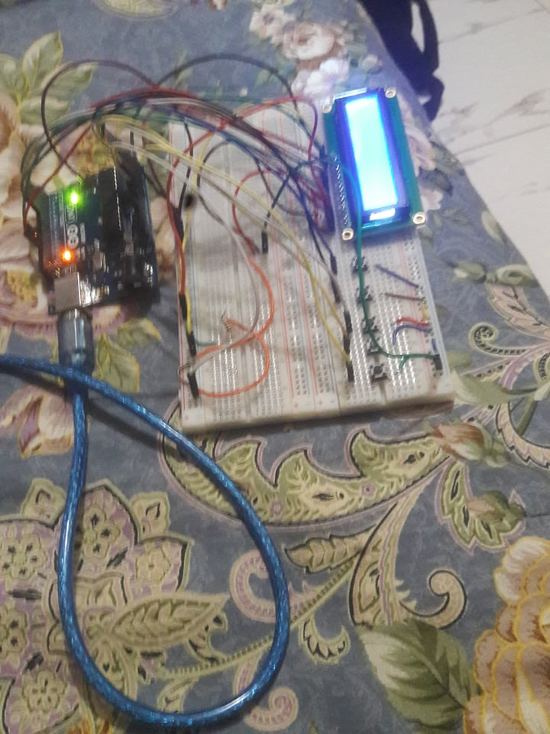

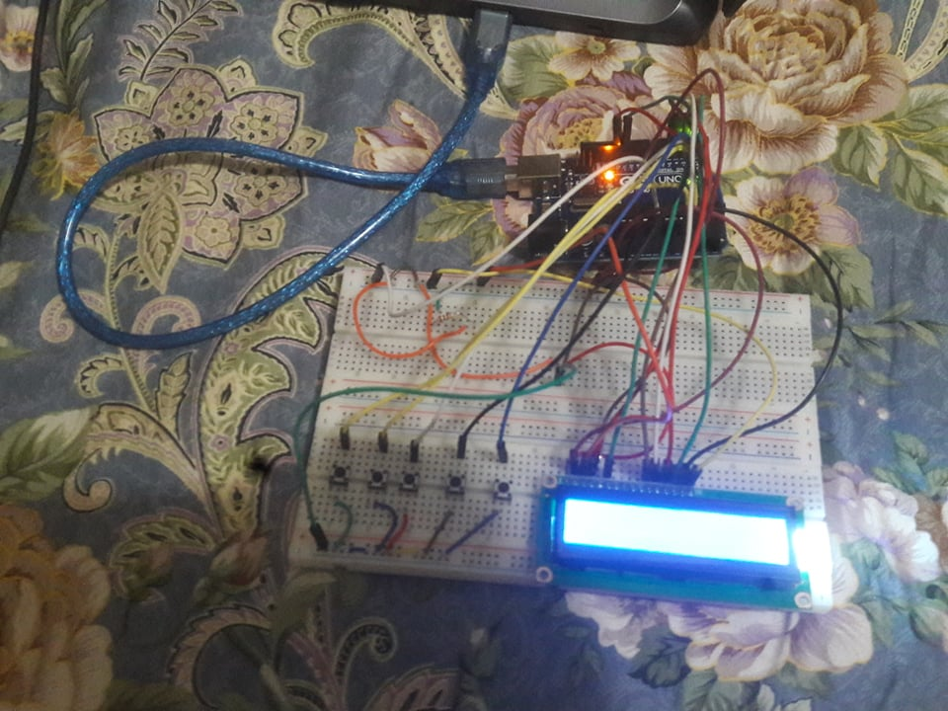

FUTURE WORK:

At the moment, our machine can receive & calculate votes. After that it declares the winner. It shows accurate result. So, it is a very simple device. But in future we want to add some features to our project

* First and foremost we want to add the fingerprint sensor with our machine. By doing this we want to complete our incomplete work. Thus, our project will be more perfect.
* We also want to create a web system and want to add it with our machine so that the final result will be shown on the website.

So, these are our future plans regarding our current project.

CONCLUSION:

We really have worked hard to construct this project. Also, we have enjoyed a lot in completing this project. It’s true that we have faced some difficulties while doing this project. Despite having those difficulties we have tried to complete our project.

Hopefully, our “ELECTRONIC VOTING MACHINE” will give accurate and precise calculation of votes.

OUR LINKS:

TRELLO: <https://trello.com/b/JwA7oePf/electronic-voting-machine>

SLACK: <https://app.slack.com/client/TLBRFKPPT/CLBRFKZDX>

GITHUB: <https://github.com/Sadman-Alam-Pranto49/ELECTRONIC-VOTING-MACHINE>